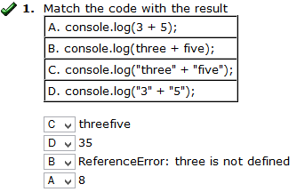

2. The variable sportsTeam has a string value of "The Detroit Red Wings." Is the following statement true or false? sportsTeam.length>20;
Correct Answer(s): | True

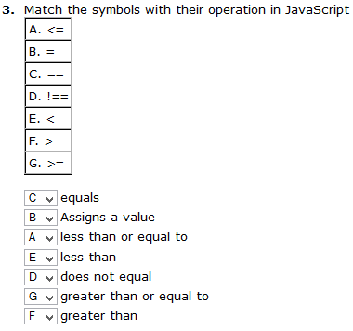
4. What code would we use to make a dialog box pop up on screen with the words "Hello User!" on it?
A) confirm("Hello User!");

5. In the box below, write an if statement that evaluates if variable ticketCost is greater than 100 and reports "Way too expensive!", but otherwise reports "Okay let's go!"

6. A variable CityName contains the name of an unknown city as a string. How could you determine the number of characters in that string?
C) CityName.length
7. What is missing from the following lines of code?
if(7>2){ console.log("duh 7 is greater than 2!")}
C) semicolon
8. Create a variable named currentSchool and fill it with a string containing the word: MSU. Don't forget to declare the variable, use proper punctuation and use correct syntax!
D) var currentSchool="MSU";
9. Time for some simple math, if I wanted to multiply the value of a variable mathNumber which contains an integer by 3, which would be the best option?
B) mathNumber * 3

1. A function could best be described as a/an...
B) ...action you ask the computer to complete
2. Which of the following is an acceptable method of declaring a function named myFunction
D) function myFunction(){//action here}
3. When naming a function you can not have a number as the first character of the function name?
A) True
4. A functions parameters must be separated by what character?
C) ,
5. A good metaphor for an array would be...
A) ...a box with ordered compartments that contain whatever I put in them
6. Arrays can contain either numbers or strings, but not both at once?
B) False

7. When I am initializing my array, what goes into the [] brackets?
E) The information I want to store in the array
8. Which of the following lines of code will assign the string "Hockey" into the 3rd position of the array mySports?
D) mySports[2] = "Hockey";
9.
Given the array below, what would be the result of the code:
console.log(myArray[1].length);
var myArray = ["I am so smart", "S-M-R-T", "I mean", "S-M-A-R-T"];
C) 7
10. In the code below, what purpose does the variable 'i' serve?
for (var i = 0, i < myArray.length, i++) {
console.log(myArray[i]);
}
A) A counter

1. Out of the following options, what best defines "design"?
C) any kind of convention, plan, or aid that will assist in development or construction
2. Which of the following is NOT an example of designing
A) a random pattern created by accident
3. Which of the following are examples of good reasons to design before you begin development of a project? Check all that apply
A) Because things are always more complicated than you think they will be
B) Because it will help you fully realize your project before you start
D) It helps keep a team of multiple people on track, especially on big projects
E) because it is a low/no risk way to experiment with the look/feel of your final project

4. What is a flowchart?
D) A diagram that represents a process, step by step
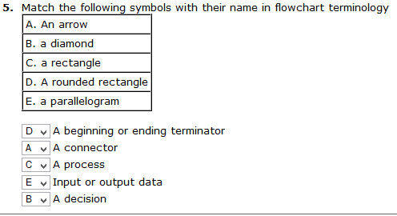

6. Which of the following would most benefit from a flowchart being made as part of the design process?
E) Designing a complicated board game

7. Which of the following best describes an object as it pertains to JavaScript?
A) A method for organizing information

8. Which of the following lines of code would create an EMPTY object named AirPlane for us to put properties into later? D) AirPlane = new Object();

9.Which of the following lines of code would add a new property to the object myResume named university with a value of the string Michigan State University?
B) myResume.university = "Michigan State University";
10. With the following code, how would you store a grade for quiz #1 of 100 for the 3rd student in the array?
D)
studentData[2] = new Object();
studentData[2].quiz1 = 100;

1. How can we best define interactivity in media?
D) Any media that responds to its user
2. What is a persona?
A) An in depth description of a single, typical user.
3. Which of the following might be most useful to include in a typical persona? Select 3.
A) Age
C) Education
E) Income
4. What is the primary concern of design in terms of interactivity?
E) To get the user to their end-goal as quickly as possible.
5. What main purpose does HTML serve in modern websites?
B) The primary content of the website
6. What main purpose does CSS serve in modern websites?
C) To create a consistent visual style
7. What main purpose does JavaScript serve in modern websites?
A) To provide interactivity
8. Which line of code would store an image labeled "vacation1.jpg" located in a folder named "myPictures" into the image property of an object "aboutMe"
D) aboutMe.image = "myPictures/vacation1.jpg";
9. Which line of code will let me change the font of the HTML id'ed header "aboutMe" to verdana?
E) document.getElementById("aboutMe").style.fontFamily = "verdana";

10. Which of the following hex codes represents the color green?
C) #00FF00

